Audiocassette Tape Digitization Guide
A. Hutchinson June 2026

Supplies Needed
- Cassette player, full-size and/or microcassette size [See images 1 through 4 in Appendix 1]
- Stereo audio cable [See image 5 in Appendix 1]
- Plugable USB audio adapter [See image 6 in Appendix 1]
- Cassette tapes to convert [See images 7 through 10 in Appendix 1]
- Audacity software—downloadable through the company portal
- Computer with a microphone or “line in” jack
- Headphones with a cord

Audiocassette Digitization Steps
- Tape Inspection Before Recording
  - Before recording, inspect the tape for damage, unwound, or loose tape from the reels, as well as any other debris. Clean the tape and make sure the tape is wound completely to one side.
  - Check that the tape does not have tabs on the top of the tape [see image 8 in Appendix 1]. If the tabs are gone, proceed with the recording. If the tabs are present, remove them using a microspatula. Once the tabs are removed, nothing can be recorded onto the tapes. This prevents us from accidentally destroying the original content by recording over it.
- Recording Process
  - Open the Audacity software.
  - Before you begin the recording process, click on the FILE tab and Save Project As.
    - This will save your work as an Audacity project and give the file a name. Follow the File Naming Documents in the Digitization binder to provide a proper name.
    - Example: 1121-065-0006_001_0006_mas
    - Be sure to save the project in your documents folder on your computer. This will be transferred to the Y: Drive Collection folder after the project is completed.
- Plug one end of the stereo audio cable [See image 5 in Appendix 1] into the cassette player’s earphone jack.
- Then plug the other end of the stereo audio cable into the Plugable “line in” or microphone jack. NOT THE EARPHONE JACK!!
- Plug your earphones into the earphone jack on the Plugable USB Audio Adapter.
- Insert the tape into the cassette player.
- Make sure the player is on and, if needed, play the tape to check the sound is clear, the tape is rewound, and that it is on the first side of the recording.
- Be sure to adjust the volume levels on the cassette player and the computer: the sound will not be clear if the volume is on the loudest setting.
- Make sure the toolbar in Audacity is displayed and that the formats below are selected. [See image 11 in Appendix 2].
- Click on the Audio Setup tab. For both the playback device (speakers) and the recording device (microphone array), the Plugable option should be checked. [See images 12 and 13 in Appendix 2].
- To listen while recording: Click on Edit—Preferences—Recording—Audible Input Monitoring [See image 14 in Appendix 2].
- To record: Click on the red record button, then press the play button on the cassette player.
- Listen to the cassette while it is being recorded to make sure the recording is going smoothly.
- Once the tape has ended on its first side, then press the pause button on Audacity and the stop button on the cassette player—if the tape does not stop on its own.
- Flip the tape to the other side. Play it to make sure there is a recording on this side, the tape is rewound all the way, and the sound levels are clear.
- If there is no recording on this side, then skip the next two steps.
- Click on the red record button and then press play on the cassette player.
- Once this side of the tape is done, click on the stop button and press the stop button on the cassette player, if it does not stop on its own.
- Once the recording is completed, DO NOT REWIND THE TAPE. This ensures we do not place additional stress on the tape.
- Save the project and export the master copy. See the Exporting Your Recording section for more details on this step.
Please Note: If you accidentally press the stop button, to begin recording again, click on the TRANSPORT tab and select the “record” option. This will restart the recording process.

Editing your Recording
- All edits should work off a copy of the original recording. Rename this copy as the access or web quality file.
- Not much editing should be taking place; just fixing any mistakes or clipping long silences that happened during the recording. We want to keep the integrity of the original tape as much as possible!
- Editing in Audacity is like editing a Word document. Select or highlight the area you wish to cut, then right-click to cut, or click on the EDIT tab, then click the cut or edit option. [See image 15 in Appendix 2].
- To add fading in/out effects: Select the area you wish to fade in or out, then click the effects tab and click on the fade in/out option.

Exporting Your Recording
- Once the recording is complete, it is time to export the recording. This ensures that the track can be listened to on other music players. If the file is not exported, it can only be replayed in Audacity as a project.
- Under the FILE tab, click on the Export Audio option.
- Click the Export to Computer option.
- Give your file the proper name [See Digitization File Naming documents for more details on naming your file] and export it into your documents folder.
- Be sure the file is saved in the WAV (signed 32-bit PCM) format.
- Before exporting, click on the Edit option at the bottom of the box. The metadata tags editor window will pop up. This allows you to enter more information about the recording. Please note that the tabs set to default cannot be changed.
- Enter the following data into the fields provided [See image 16 in Appendix 2]:
  - Artist Name: Interviewer’s Last name, First name (if applicable)
  - Track Title: Interviewee’s Last name, First name (if applicable)
  - Album Title: Collection Title
  - Track Number: Item Number
  - Year: Date if known as Year—Month—Day
  - Genre: This is for music only
  - Add additional tags by clicking the “Add tab” option. Then include the information below:
    - Digitized By: Last name, First name
    - Digitized Date: Year—Month—Day
- After the tags are filled out properly, click on Okay, and Audacity will export the file.
- Be sure to export BOTH the master copy (first recording) and the access copy (edited recording). Use the same metadata tags for both.
- Transfer BOTH copies to the correct Y: Drive Collection folder.

Microcassette Digitization Steps
- Tape Inspection Before Recording
  - Inspect the tape for damage, unwound, or loose tape from the reels, as well as any other debris. Clean the tape and make sure the tape is wound completely to one side.
  - Check that the tape does not have tabs on the top of the tape [see image 8 in Appendix 1]. If the tabs are gone, proceed with the recording. If the tabs are present, remove them using a microspatula. Once the tabs are removed, nothing can be recorded onto the tapes. This prevents us from accidentally destroying the original content by recording over it.
  - Before recording, check the playback of the tape. If it sounds funny, check that the player iso n the right speed. The speed can be found on the left side of the microcassette player. The majority of tapes will be on the “24-speed” setting. [See Image 4 in Appendix 1]

- To Record:
  - Plug one end of the stereo audio cable [See image 5 in Appendix 1] into the cassette player’s earphone jack.
  - Then plug the other end of the stereo audio cable into the Plugable’s “line in” or microphone jack. NOT THE EARPHONE JACK!!
  - Plug your earphones into the earphone jack on the Plugable USB splitter.
  - Insert the tape into the cassette player.
  - For the recording process, see the Audiocassette Digitization Steps.
  - For editing, see Editing your Recording.
  - Once the recording is completed, DO NOT REWIND THE TAPE. This ensures we do not place additional stress on the tape.
  - Export your project from Audacity. See the Exporting Your Recording Steps.

Additional Resources
Online guides for conversion
Microcassettes:
- Arapahoe Libraries Converting a Microcassette to Digital (MP3): https://arapahoelibraries.org/blogs/post/converting-a-microcassette-to-digital-mp3/
- Case Western Reserve University Audio Digitization Microcassette Tapes: https://researchguides.case.edu/audio-digitization/tutorial/play-microcassette
Audio Cassettes:
- BH Photo: https://www.bhphotovideo.com/explora/audio/tips-and-solutions/how-record-cassette-tapes-computer
- WikiHow: https://www.wikihow.com/Transfer-Cassette-Tape-to-Computer
General Support:
- Library of Congress Digital Preservation Page: https://www.loc.gov/preservation/digital/
- University of North Texas Digitizing Analog Audio Recordings: https://ci.unt.edu/corsal/trainings/curriculum/16-digitize-transfer.html
- North Dakota State Library Digital Projects Toolkit—Audio: https://library-nd.libguides.com/digitalprojectstoolkit/audio
Audacity Support:
- Audacity Download: http://www.audacityteam.org/
- Documentation: http://www.audacityteam.org/help/documentation/
- Online Manual: http://manual.audacityteam.org
- Audacity Wiki Page: https://helpwiki.evergreen.edu/wiki/index.php/Audacity_Tutorial
- Tips on transferring recordings to Audacity from audiocassettes: http://manual.audacityteam.org/man/sample_workflow_for_tape_digitization.html
- Tips for transcribing tapes on Audacity: http://manual.audacityteam.org/man/faq_about_audacity.html#transcribe
- Editing in Audacity: http://manual.audacityteam.org/man/tutorial_editing_an_existing_file.html

Appendix 1: Photographs of Digitization Tools

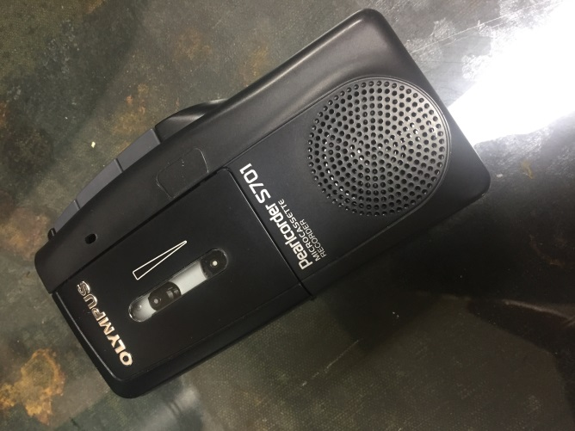
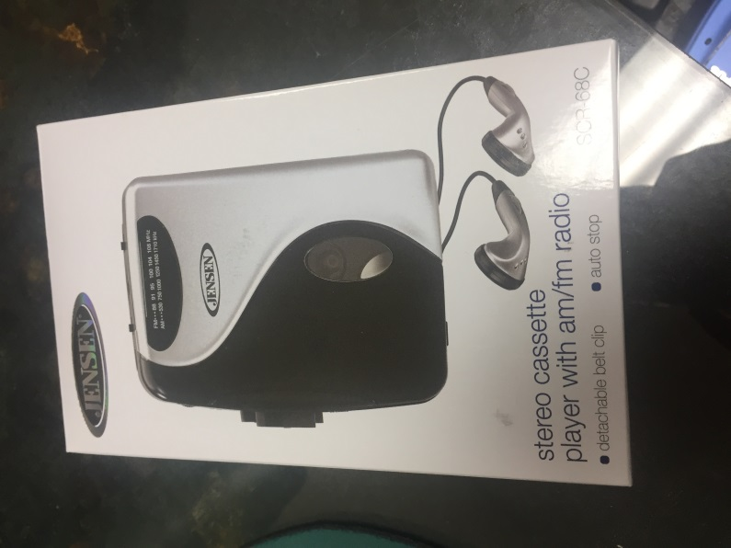

Image 2: Microcassette Player
Image 1: Audiocassette player in box

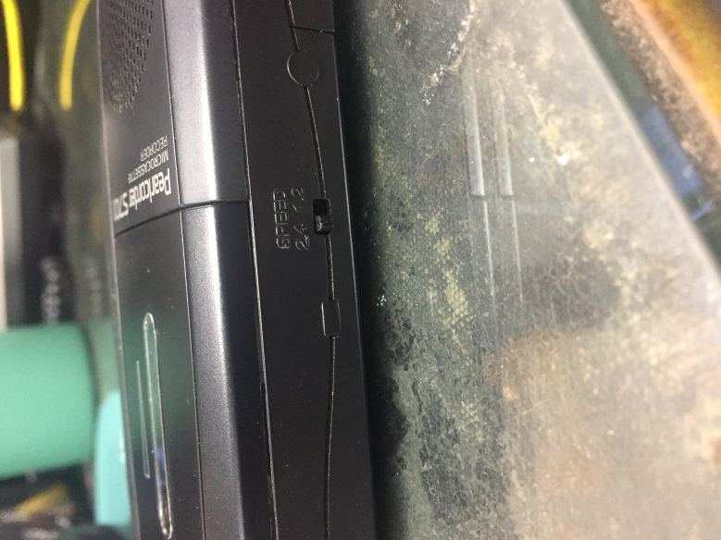
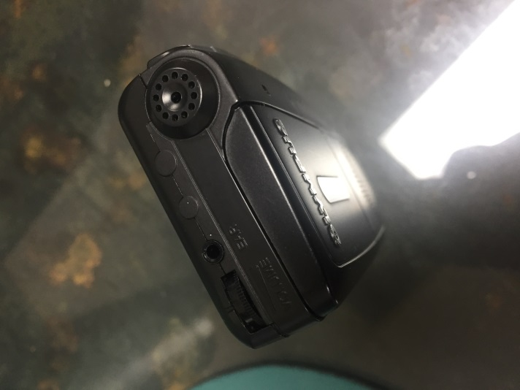

Image 4: Microcassette tape player—speed selection
Image 3: Microcassette tape player—view of the top; earphone jack

Appendix 1: Photographs of Digitization Tools Continued
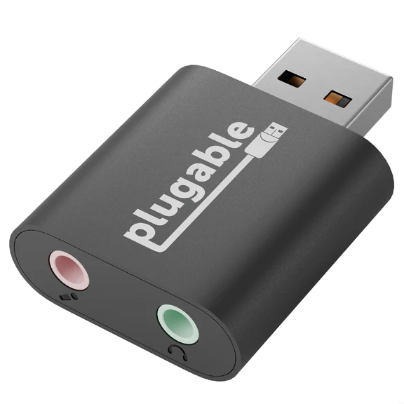
Image 6: Plugable Audio Adapter
Image 5: Stereo Audio Cable

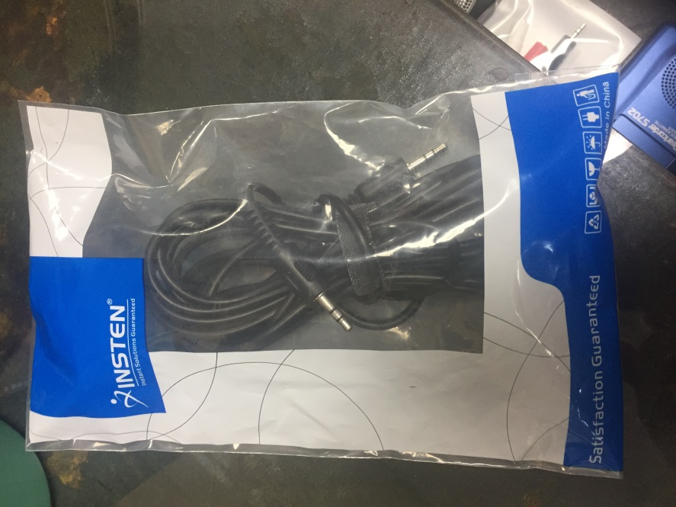
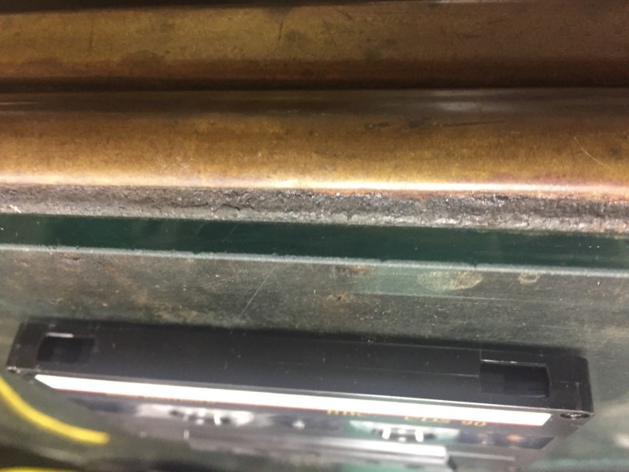
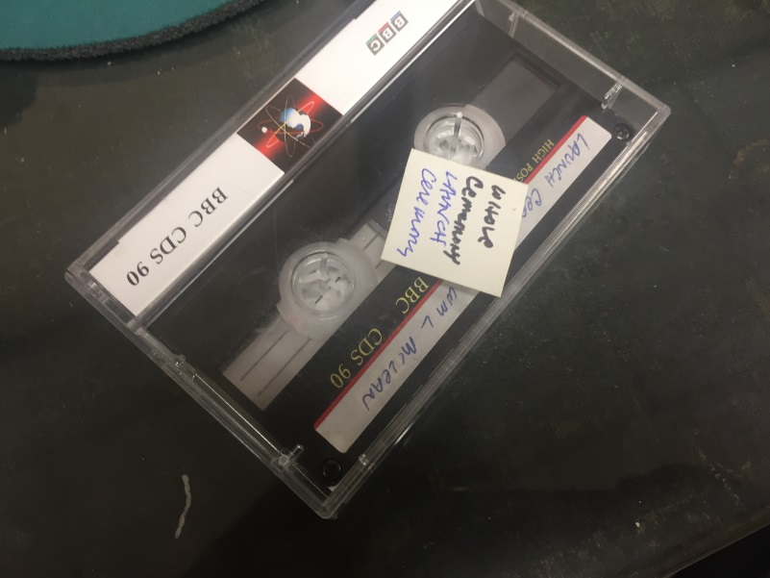
Appendix 1: Photographs of Digitization Tools Continued
Image 8: Audiocassette tape—top view; tabs removed
Image 7: Audiocassette tape

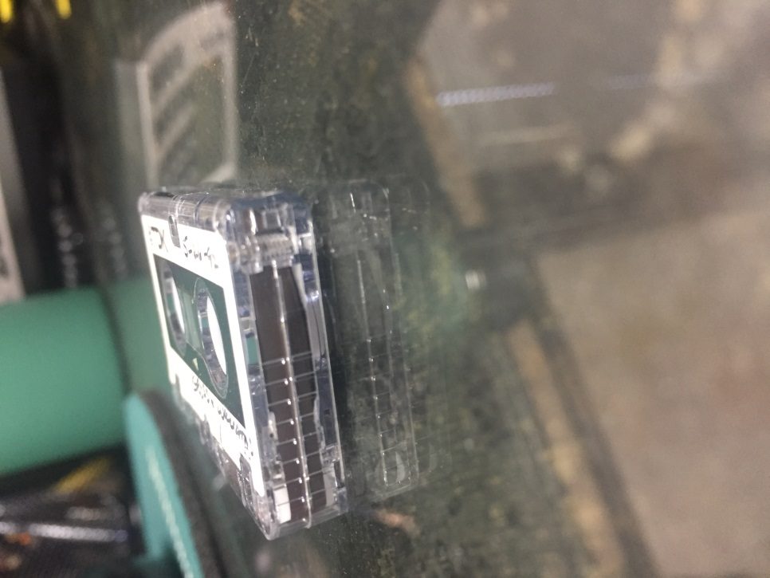
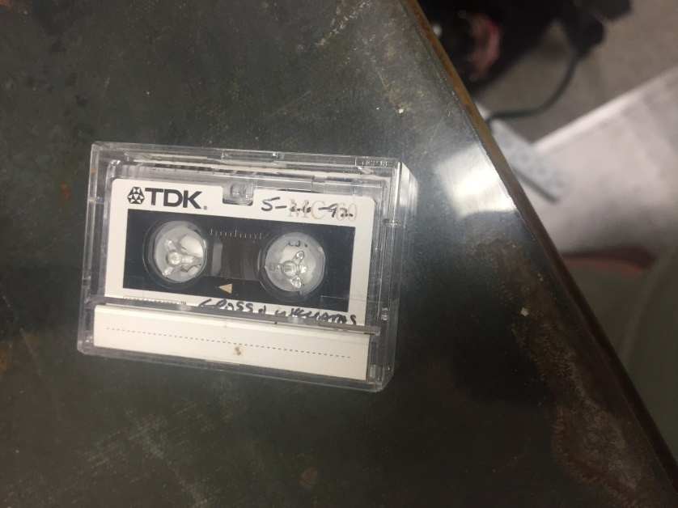
Image 10: Microcassette tape—side view; tabs not removed
Image 9: Microcassette tape

Appendix 2: Audacity Screenshots

Image 11: Audacity Tool Bar

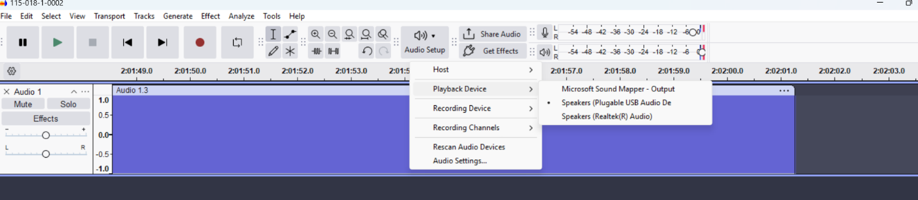
Image 12: Audacity: Playback Device—Speakers Settings

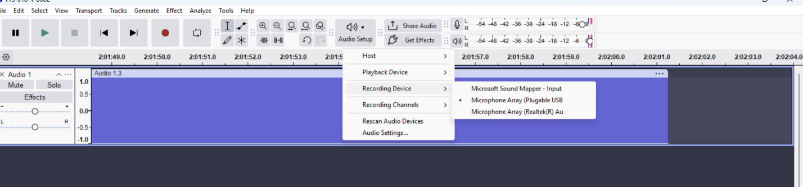
Image 13: Audacity: Recording Device—Microphone Settings

Appendix 2: Audacity Screenshots Continued

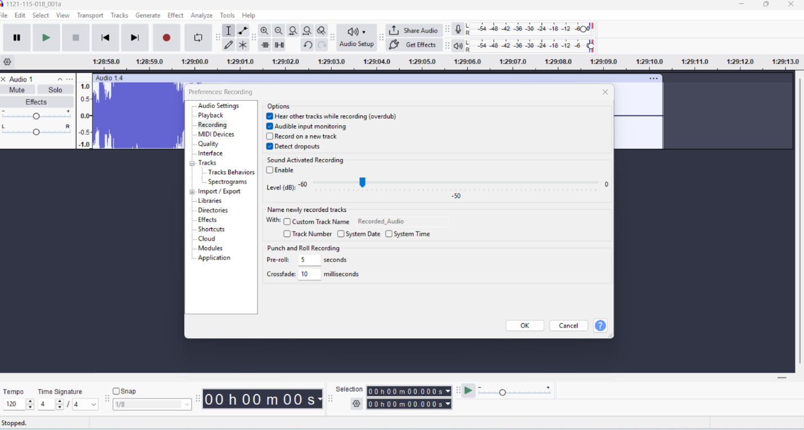
Image 14: Audacity: To Set Up Listening While Recording Option

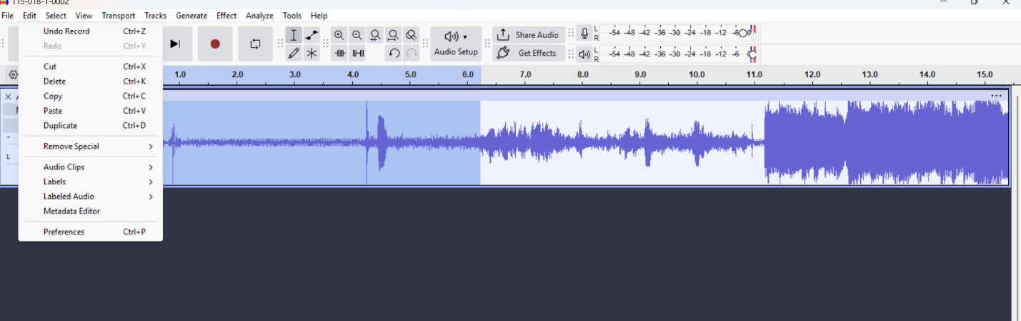
Image 15: Audacity: Editing a Recording
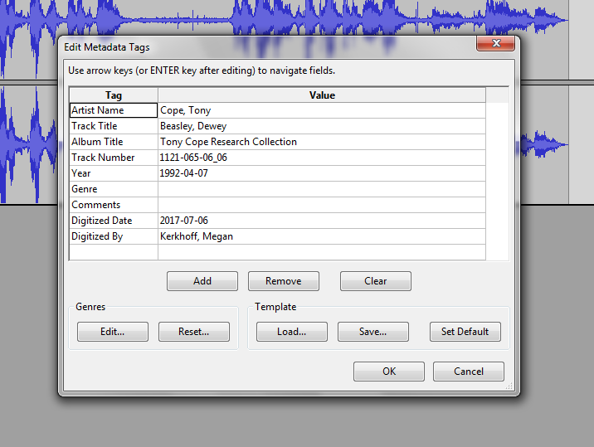
Appendix 2: Audacity Screenshots Continued
Image 16: Audacity: Metadata Tags Edit Window—example of the information that should be entered into the fields.

